Ortega Community Ditch

**How to Register Your Water Rights**

**Prepared by Kim Martin, La Mesilla Community Ditch**

**Edited with permission 2016**

New Mexico State Law requires that you register your water rights (72-1-2.1). *“In the event of any changes in of ownership of a water right.........the new owner of the water right shall file a change of ownership form with the state engineer. The form shall include all information conforming with water rights of record filed with the state engineer and shall be accompanied by a copy of a warranty deed or other instrument of conveyance.”*

To register your water rights on the Ortega Community Ditch, take a copy of your warranty deed (or other instrument of conveyance that you believe shows your rights to the water) to the Office of the State Engineer. That paperwork must show a stamp from the Rio Arriba County Clerk. It may also be useful to know the names and locations of some of your (nearby) neighbors who have already registered their water rights. Your rights must be traceable back to one of the original owners of water rights on the Ortega Community Ditch, so anything you have that allows a clear chain of your rig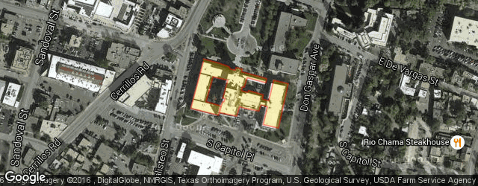hts back to one of these owners (title insurance, etc) may prove to be useful. **You MUST make an appointment; their telephone number is 505-827-6120.**

This office is located in the Bataan Memorial Building in Santa Fe (407 Galisteo Street, Santa Fe.) There is a metered parking lot on the west side of the building (Galisteo Street), but sometimes it is easier to park in the municipal (fee required) parking lots on Don Gaspar or on W. San Francisco. It is a short walk to the Bataan Memorial Building from either lot (the Don Gaspar lot is closer).

From the west entrance of the building go up the stairs to the entrance and then through the foyer that showcases some sculptures. Go through the courtyard area and straight down the first floor hallway to Suite 102. The people at the desk there will help you.

There will be a $5.00 fee for every registration. If your well is not in your name, you should register that also.

You must also register with the Santa Cruz Irrigation District (north side of the plaza near the Santa Cruz Church). Their phone number is 505-753-2195. Then you need to register with the Ortega Community Ditch.

**How to Look Up Your Water Rights Online**

The state engineer has a website where you can look up your water rights online. You can examine the registration of your well (RG; Rio Grande Basin) or of your water rights on the acequia (SD; Surface Declaration).

1. Go to the state engineers website at: <http://www.ose.state.nm.us/WRAB/index.php>
2. Follow the Steps 1-4 on the website. (If you have a problem with later steps, it is likely because your pop-up blocker is still on.
3. Step 4 takes you to a page that looks like this:
   1. Click on the third bullet down; Water Right Summary
4. The next page has two tabs, to look up your rights by the File number, just enter the number. If you don’t know the number, click on the Owner Name tab. The basin (in either case) is RG (for your well) or SD for your surface water rights.
5. Use the pull down menu for basin to choose RG or SD. Enter your file number (if you are on the file number page) or enter your first and last name (if you are on the owner name page). This database is very specific. You will not find your name unless you enter it exactly as it is in the database. It is best to use a wildcard search. For a name like Maximillian Montoya, type in something like Ma* Mont*. That way, the database will find variations such as Max Montoya, Max A. Montoya, Maximillia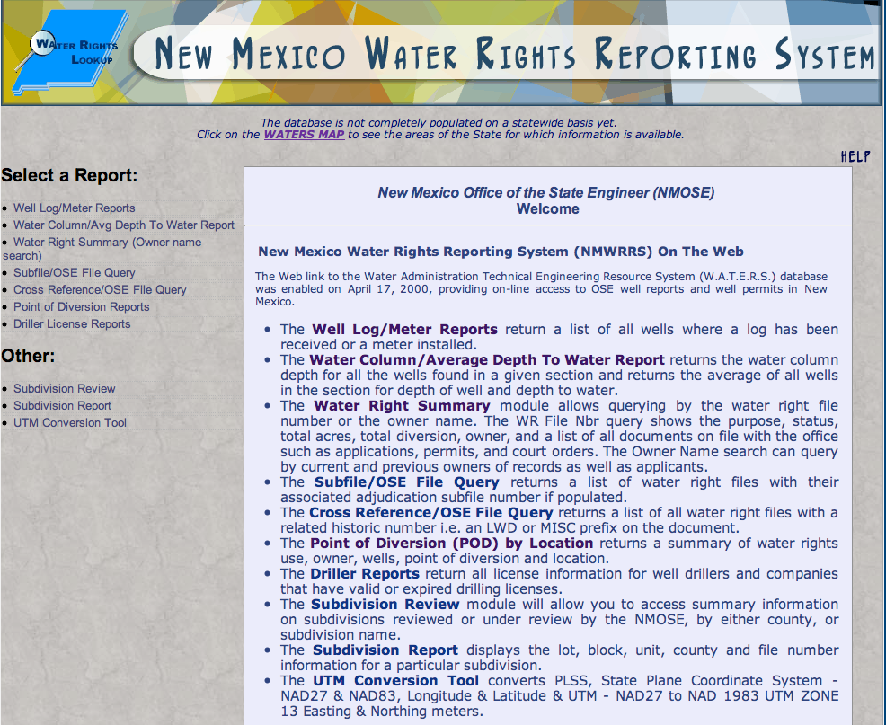n A. Montoya, Maximillian Montaño, etc.
6. A pop-up will show up with the names that match what you have typed in with a file number. Click on the file number and you will be taken the Water Rights Summary page. If you click on the “get images” part of the page, you will (usually) be taken to a Transaction Summary page. If you click on the “get image” on that page, your file information will usually be displayed.
7. If nothing familiar comes up under SD 02416, check the database with some of your neighbor’s names and note the file number that comes up. The numbering system reflects how the water rights were split as land has been divided. For example, .the original owner’s file number may have been something like SD 02416 42. To see everyone who has water rights from that original property; go back to the file number page, use the pulldown menu to choose basin SD, type in Nbr 02416, and then type in 42* as the suffix. Water rights for 42, 42A, 42B, 42BA are displayed.
8. Sometimes there are errors in the database. Misspelled names are not common but are not unknown. If you know you have registered your rights, and you want copies of your paperwork, then you must contact state engineer to discuss the issue (505-827-6120).